SIMATS ENGINEERING (SAVEETHA SCHOOL OF ENGINEERING)
Department of Computer Science and Engineering

ASSESSMENT TOOL 2 – Industry Problem Solving Task
Course Code: | CSA0612 | Course Title: | Design and Analysis of Algorithms
CO Assessed: | CO4: Articulation (BL4, BL5) | Assessment: | Assessment Tool 2 – Industry Problem Solving  Task
Weightage: | 20% of CIA | Total Marks: | 100
CO4 Statement: | Solve optimization problems using dynamic programming and greedy strategies.
Student Name: | SRINIVASAN A | Reg. No.: | 192411025
Section / Batch: | 2024/CSE | Date: | 21.08.2026

Criteria | Weightage | Level 4 – Exemplary | Level 3 –  Proficien  t | Level 2 –  Developing | Level 1 –  Beginnin  g

Instructions

to

Students

•

Answer

the

following

question.

Total

Marks:

100.

•

Carefully

analyze

the

given

questions.

•

Explain

in

detail

with

sample

code

if

needed.

•

Clearly

identify

all

key

issues.

•

Provide

a

thorough

analysis

with

validated

results

and

performance

evaluation.

Question Type | Focus Area | Questions
Industry Problem  Solving Task | Focus on Solving optimization problems using dynamic programming and greedy strategies | Q1

SECTION

A

–

Industry

Problem

Solving

Task

Code

of

Conduc
t

I

SRINIV

ASAN

A

-

192411025

(
Name

/

Reg

No)

certify

that

this

submission

is

my

original

work

and

that

I

have

adh
ered

to

the

guidelines

specified

for

this

assessment.

I

understand

that

any

violation

of

academic

integrity

rules

will

result

in

disciplinary

action.

Signature

of

the

Student:

SRINIV

ASAN

A

RUBRICS FOR CALCULATION

Industry Problem Solving Task
Understanding of Industry Problem | 20% | Comprehensive understanding of real-world  problem and constraints | Good understanding  with minor gaps  in  requirements | Basic understanding; some  requirements unclear | Poor understanding; misinterprets problem context
Application of  Engineering  Concepts | 25% | Applies advanced and relevant concepts  effectively to solve the problem | Applies appropriate  concepts with  minor errors | Limited application of concepts | Incorrect or no application of concepts
Solution Design | 25% | Innovative, practical, and  feasible solution aligned with industry standards | Logical and feasible solution with minor gaps | Basic solution with limited  feasibility | Unclear or impractical  solution
Use of Tools | 15% | Effective use of modern tools,  technologies, and real data | Appropriate use of tools with correct  implementation | Limited or inconsistent use of tools | Minimal or incorrect use of tools
Analysis | 10% | Thorough analysis with validated results and  performance  evaluation | Good analysis with reasonable validation | Basic analysis with limited  validation | Poor or no analysis
Professionalism | 5% | Highly professional,  well-documented, and clearly presented work | Good documentation and presentation | Basic documentation with some gaps | Poor documentation and presentation

Marks Evaluation:
Criteria | Wt. | Level 4 –  Exemplary | Level 3 –  Proficien  t | Level 2 –  Developing | Level 1 –  Beginning
Understanding of Industry Problem | 20%
Application of Engineering Concepts | 25%
Solution Design | 25%
Use of Tools | 15%
Analysis | 10%
Professionalism | 5%
Total Marks (100):

Faculty In-charge | Course Coordinator | Head of Department
Name: | Name: | Name:
Signature: _______________ | Signature: _______________ | Signature: _______________
Date: ___________________ | Date: ___________________ | Date: ___________________

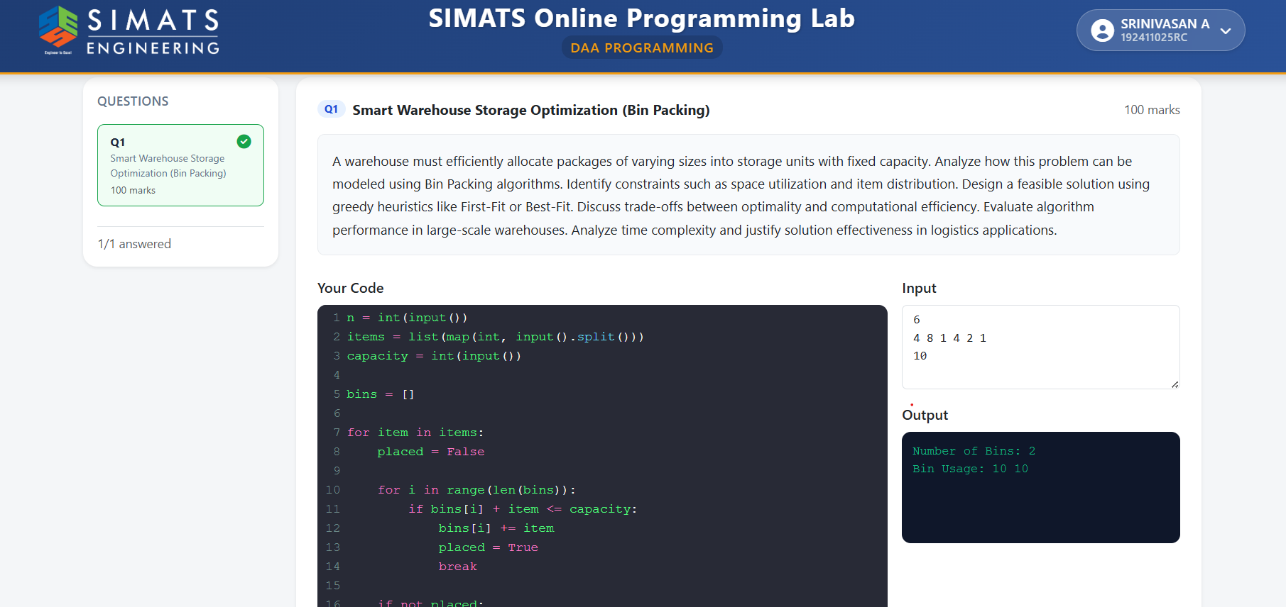

Algorithm: Smart Warehouse Storage Optimization – First-Fit Bin Packing
- Start
- Input the number of packages n.
- Input the size/weight of each package.
- Input the fixed capacity of each storage bin.
- Initialize an empty list of bins.
- Take each package one by one.
- Compare the package size with the remaining space in the first bin.
- If the package fits, place it in that bin and update its used capacity.
- If it does not fit, check the next available bin.
- Continue checking until a suitable bin is found.
- If the package cannot fit in any existing bin, create a new bin.
- Repeat Steps 6–11 until all packages are stored.
- Count the total number of bins used.
- Calculate the space used in each bin.
- Display:
- Number of bins used
- Items/space stored in each bin
- Overall space utilization
- Stop

